PARENT HANDBOOK

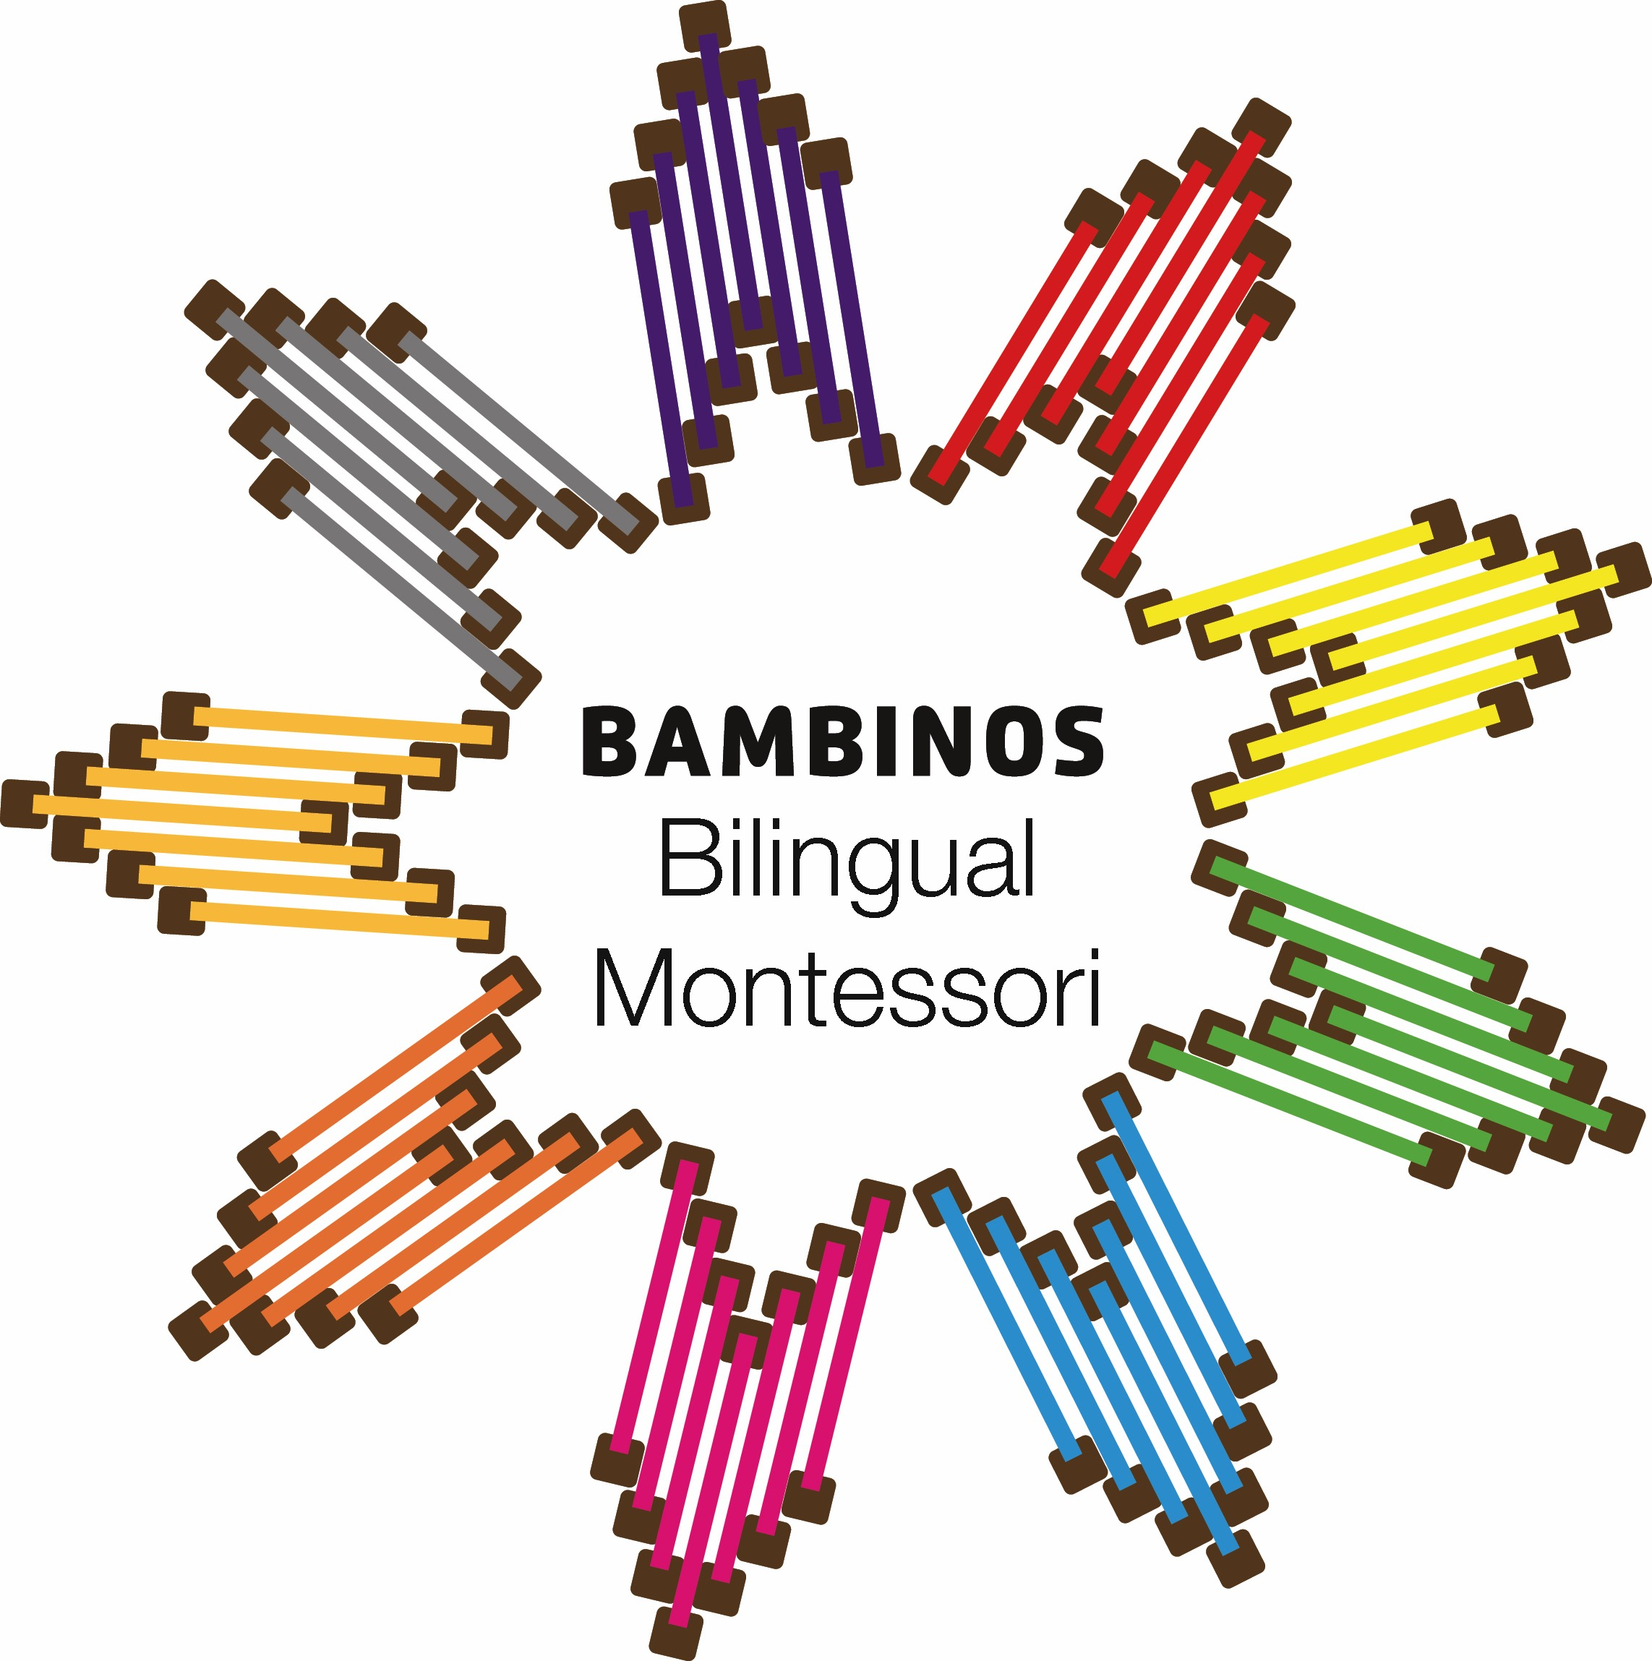

General Information - Bambinos Bilingual Montessori ’s Philosophy

Our daycare is proud to provide children with an outstanding opportunity for Montessori Education. Children at Bambinos Bilingual Montessori Daycare interact within the prepared classroom environment working at their own developmental learning pace. Both individual and group learning experiences are emphasized within each classroom using Montessori materials. Content learning includes social interaction; work in the practical life and sensorial areas, music and art. They are also exposed to language, Spanish, Math, Botany, Zoology, History and Geography. These rich layered strands of curriculum build progressively as a student advances through the Montessori educational levels.

The self-esteem, self-confidence and inner direction of children who receive an early childhood Montessori education serve students into their elementary school years. It is the intent of Bambinos Bilingual Montessori Daycare to build a solid personal as well as academic foundation in each child propelling them into a bright future full of personal satisfaction, feelings of self-fulfillment and success in social encounters and confidence in areas of challenge.

Maria Montessori said, “Play is a child’s work.” This Montessori principle believes that children learn by doing “works.” Doing “works” promotes focus on Respect for self, respect for each other and respect for the classroom environment. Therefore, classrooms become small communities. At Bambinos Bilingual Montessori, each classroom has Montessori materials designed to fit individual children’s needs, creating meaningful learning experiences maximizing each child’s abilities. Teachers follow a daily routine of active learning so that students can cover important curriculum vital to overall child development. The prepared environment invites interaction between children, materials and the guiding teacher. Montessori materials create appeal, capturing a student’s inner curiosity while allowing a student to move naturally through stages of their development and levels of learning. Traditional educational methods are integrated along with Montessori methods to provide structure and assessment verifying that the child experiences all areas of learning. Regular attendance at Montessori is critically important to your child and to our program. Arriving on time is respectful to teachers, assistants and to classmates since lessons begin with “circle time” at 8:30 a.m.

Montessori Curriculum and The Montessori Method

The Montessori method is founded on the principle of respect: respect for self, respect for others and respect for our environment. Bambinos Bilingual Montessori classrooms are designed to create an environment that is calm, ordered and realistic for the child. The materials and furniture are all sized for the children’s learning and exploration. Teachers at Bambinos Bilingual Montessori are unobtrusive in the learning process, as he/she respects the child and his/her choices. Children are active participants in their learning and are encouraged to work independently or in groups. Children follow what interests them and the teacher responds with appropriate and individualized lessons. Both individual and group instructions can vary based on each students learning style, as the Montessori teacher adapts to individual needs. Each child sets his/her own learning pace to internalize information gleaned from “works” of their own choosing and ability level. The teacher relies on his or her observations of the children to determine which new activities and materials he/she may introduce to individual, small or large groups.

Within the multi-age classroom community, more experienced older children share what they have learned by helping others learn and thereby reinforcing their own learning. Creativity flourishes in this atmosphere of acceptance and trust. The rich curriculum, under the direction of the Montessori teacher, allows each child to experience the joy of learning. The classroom community encourages self- direction, through non-competitive activities. This aids the child in developing a strong self-image and sense of self-esteem, which is critical when building an attitude of learning and exploration to last a lifetime.

Tenets of Montessori

Children are unique, capable individuals who are to be respected as different from each other.
Children are extremely perceptive, “absorbing their world between the ages of birth and six
years”.
Children should have freedom of choice coupled with responsibility for their choices.
Children learn best when they follow what interests them.
Teachers should model and reinforce positive behaviors.
Children should lead and direct their learning, whereas teachers should follow and enhance those
learning experiences.

Positive Behavior Management

The Montessori principal of teaching and modeling respect for self, for others and for the environment gives children opportunities to make appropriate choices in behavior. Routines in daycare encourage self-discipline in children and social skills are acquired and developed at Bambinos Bilingual Montessori.

Our trained staff will use a variety of developmentally appropriate behavior management techniques to direct/ redirect your child in a positive, clear and relaxed manner. These management techniques, called positive discipline, help children:

- Learn to make good choices.
- Learn problem-solving skills.
- Learn basic values of respect, trust, and responsibility, honest and caring for others.
- Learn to communicate their needs.
- Be encouraged in self-control.
- Learn self-discipline

Staff will manage inappropriate behavior with redirection of alternative activities, and verbal conflict resolution while promoting and teaching Montessori values and techniques of positive discipline. Bambinos Bilingual Montessori strictly prohibits spanking or any form of corporal punishment, physical or mechanical restrain, the withholding of food or water or any form of emotional abuse.

Staff is trained in positive discipline management techniques to achieve student success. Staff indicates the desired behaviors directly to children. Repetitions of requests are made calmly but firmly.” Please use walking feet so that you don’t fall down” or “This is a one person job.” “Let’s find something else to do.” Discipline is always age appropriate. The words “time out” has evolved to mean different things to different people. Consequently, at Bambinos Bilingual Montessori, We use “thinking time”. During thinking time, the child sits quietly to think and returns when they are “ready” to rejoin work/group or when they are invited back to the activities of the classroom.

Parent of children who have difficulty within a Montessori environment will:

1. Meet with the teacher
2. Meet with the teacher and head of Daycare,
3. Have the child observed by a psychologist and /or childcare services specialist/ CCS, or nurse

Montessori Areas of Study

Practical Life: The purpose of practical life exercises is to encourage conscious, orderly, controlled and functional knowledge out of the mass happenings in the real world. The practical life exercises help a child break down jobs at hand into easily manageable components.
They all require real tools: silverware, wood, glass etc., and all things that reflect and typify an actual home environment. In this way, they provide the child a chance to learn what practical living is and how to manage it. The main areas in the practical life exercises involve grace and courtesy, care of person, care of the indoor environment and art.

Grace and Courtesy: Critical areas of practical life that are often underdeveloped are grace and courtesy. Lessons in the language of respect and lessons in control and coordination of movement are taught and practiced throughout the day for the children at Bambinos Bilingual Montessori. Simple things such as: saying please and thank you, saying excuse me, politely blowing one’s nose, politely covering one’s mouth in a yawn or cough and apologizing when appropriate.

Sensorial: This area deals with size, shape and color. The sensorial materials are designed to aid the child in training and refining his/her five senses. Children are exposed to concepts of size, shape and color and challenged to make judgments about them. By using the sensorial materials, the child learns to recognize similarities and differences; to discriminate between similar objects and to categorize similar objects. Each set of materials is used as carefully and precisely as possible. Precision at this stage prepares for later work in geometry.

Language: Montessori children typically do not remember learning to read, as the environment is designed so that all experiences feed naturally towards the development of skills required for reading. It was not only Maria Montessori’s trust in the child’s power that lead her to approach reading in this natural way, but also her concept of the child as an active, rather than receptive being. She considered it the job of education not to fill the child with the techniques for reading, but to free the child for self-expression and communication. Therefore, although reading, writing, spelling and grammar are introduced to the child in an organized phonetic method, the presentation allows the child to acquire reading skills without realizing the effort.

Mathematics: Math is the study of numbers, quantities, shapes and measurements and how they relate to one another. In Montessori math, the children are introduced to the concrete sensorial impressions of numbers, the decimal system and its functions, addition, multiplication, subtraction and division. Using manipulative materials, the child explores these concepts physically, creating a basis for more abstract operations.

Geography/Culture: Geography is the study of the earth including its people, resources, climate and physical features. Teaching geography aids the child in developing a clear sense of spatial orientation, by giving sensorial impressions of the earth and showing children their relationship to it. Montessori lessons help develop a foundation of global awareness. In addition, geography lessons explore different world cultures. Through exposure to cultural traditions and lifestyles, geography lessons allow the child to become aware of and develop respect for all cultures, which is critical in today’s global community.

Because he/she is young, the child is willing to work and is receptive to direction. He/she works for the simple joy of doing the task at hand, so early childhood is the ideal opportunity to give him/her the tools of learning and give him/her the methods to use them. The teacher is an important catalyst, allowing the child to repeat the task for its own sake. The teacher also helps him/her appreciate the value and dignity in the work itself.

As the child builds success upon success with small tasks, he/she is able to go on to greater ones, mastering his/her small environment.

Botany: Exploring the subject of botany helps a child develop an appreciation for and an understanding of the life cycle. Through specific botany works, the child develops a greater knowledge and understanding of the virtue of patience as the child is exposed to nature’s seasonal changes and the growth cycle.

Spanish: A fun and easy language to learn! Children will remember Spanish if they learn it while having fun, using speed learning techniques such as music, pictures, color, patterns, associations and games played within the classroom.

Daycare Policies and Procedures

Families of eligible children must be willing to make an extraordinary commitment to their child’s education and a commitment to the daycare’s mission and education. Commitment to the daycare’s mission and educational philosophy manifests itself in the signing of the registration forms.
Pre - Admission Tour and Visit

Parents are invited to visit our Daycare facility to observe our teachers and students in the classroom prior to enrolment. It allows Bambinos Bilingual Montessori to explain our philosophy, educational methods and our facility to the visitor. Additional reading material is given for review at home. With this review, parents can ensure that Bambinos Bilingual Montessori is a quality choice for their family and that their choice is a commitment for involvement in the community.

Enrollment

Upon your decision to enroll your child, Bambinos Bilingual Montessori requires $100.00 non-refundable enrolment fee to cover administrative costs and student materials at the time of registration along with a completed and signed registration form.

Required Admission Forms

Upon your decision to enroll your child at Bambinos Bilingual Montessori, you will be asked to complete the following forms. Completion of these signed forms is required prior to your child’s first day of attendance:

- Registration Form Student Update
- Medication Consent (If applicable)
- Certificate of Immunizations Status
- Student Pick up Authorization
- Parents Acknowledgements
- Student Information Survey
- Tuition Plan Acknowledgement
- Notice Of Allergy
- Volunteer Form

Childcare Day Program

The childcare Program operates from 8:00 a.m. to 3:00 p.m. After 3:00 p.m. its free activity time (craft, movement activities, yoga, art, reading, finger play, sing songs or table top activities) till 5:00 p.m. daily. Regular attendance at school on your schedule days is critically important to our program. Arriving on time is respectful to teachers, assistants, and to classmates. Families who repeatedly arrive late or maintain sporadic attendance will be asked to reconsider their commitment to their child’s education at Bambinos Bilingual Montessori.

Families with students enrolled in the Bambinos Bilingual Montessori program may occasionally request emergency childcare with 24 hours of the anticipated need. Emergency childcare is billed to the family account at the rate of $12.50 per hour.

Daily Programming

Daily Schedule is designed to keep the child busy throughout the day. It is intended to assist the staff with non-stop activities and to prevent repetition. The designated rooms are set up following the guide for Montessori Curriculum.

Transitional Period

At the time your child is enrolled, a schedule will be set in motion to familiarize your child with our daycare to create a positive transitory experience. The classroom teacher and administrative staff are flexible and willing to work with you on that schedule so your child has ample opportunity to adjust to our classroom/ childcare routines and can settle in as early and comfortably as possible.

The first 30 days of attendance at Bambinos Bilingual Montessori is a transitional trial period for your child and for Bambinos Bilingual Montessori. You are encouraged to speak regularly and consistently with your child’s teacher to discuss how the adjustment process is proceeding. Teachers can often suggest a variety of strategies to maximize success for your child during this time.

At any time during the transitional period, either the daycare or the parent may request a conference to discuss whether Bambinos Bilingual Montessori can adequately meet the needs of your child. Montessori is not always ideal for students needing small class sizes, intense social skill strategies or behavior management interventions.

On any school day, parents are allowed to access, by appointment, to any area of the Daycare that their child uses. Scheduling a time to visit a classroom in advance will allow you to observe your child participating in a specific activity. Appointments with teachers are necessary to address your child’s progress in the classroom.

Arrival

We strive to keep the atmosphere within the school and classrooms child-centered. It is disturbing to children when parents linger in or near the classroom. It is specifically for this reason that the arrival and departure arrangement is followed. It is very important for your child to be at school by 8:00 a.m.- 8:30 a.m. on your scheduled days. Arriving on time is respectful to teachers, assistants, and to classmate. We take our commitment to your child’s education seriously.

When your child is not picked up by 5:00 p.m., we will contact the parents listed on the child’s information updated form to notify them. A late fee of $ 1.00 per minute will be charged for each minute the parent is late and $ 2.00 for the second occurrence within 30 days.

Lunch

Your child should eat breakfast to arriving at Bambinos Bilingual Montessori each morning. Parents are responsible for packing a lunch and snacks for their child in an appropriate container with a cold pack. Cold packs in lunches are required to keep food cold and safe. Lunches are eaten in the classrooms. Bambinos Bilingual Montessori provides placemats and positive manners are modeled and encouraged. Lunch is a quiet and social time when good manners and polite conversation are encouraged. Many children set out their own lunches and all are required to tidy up after eaten. Please send a balanced nutritional lunch for your child. Please pack healthy “body” food. Suggestions include pasta, sandwiches, string cheese, cheese snacks, fruit, and yogurt, vegetables w/ dip, fruit snacks or roll ups. DO NOT SEND CANDY, SODA, COOKIES, SUGARED CRAKERS, DESSERTS OR FOODS WITH A HIGH SUGAR CONTENT. Any foods with high sugar content will be returned home, for enjoyment at home.

We do not allow students to share lunches with each other. We return uneaten food in lunch boxes, so parent will know how much each child is eating. Each classroom has a microwave to warm up lunches, if needed. Below are some ideas for healthy lunch choices:

1. Fresh or dried fruit
2. Vegetables raw or steamed
3. Cheese slices or sticks
4. Fruit Juice make sure 100% juice
5. Yogurt
6. Raisins
7. Rice cakes
8. Granola Bars
9. Trail mix
10. Sandwiches
11. Leftovers from healthy dinners
12. Crackers
13. Fruits

Please label all lunch boxes, containers, and cold packs with your child’s name. If you would like your child to drink something other than milk or water you must send it daily in their lunchbox. We cannot refrigerate any beverages.

Naps and Rest Periods

Bambinos Bilingual Montessori provides cots and blankets that will be labeled with the child’s name. These classes will have group naptime during early- afternoon. They sleep in their on cots in the room area. Bambinos Bilingual Montessori cleans the blankets weekly on Fridays. Children who do not fall asleep rest quietly and may be offered a book or other activities so that they do not disturb other sleeping children. Naptime is part of our routine and children need to rest in order to recover energy for the next activities.

Diaper Procedures

Parents provide disposable diapers and wipes for infants & toddlers. These supplies will be stored at Bambinos Bilingual Montessori Daycare in containers labeled with your child’s name. These supplies will not be shared between children. Children will be changed every 2 hours if they are wet. Parents, teachers and teaching assistants confer frequently regarding diapering care.

Any diapering creams can be administrated only with a doctor’s note and medication consent from signed by the parent.

Toilet Training

Teachers will work with parents to facilitate successful toilet training. Parents are strongly encouraged to share their toilet training plan with teachers and staff to ensure a successful consistent training experience between daycare and home. Frequent communication on a child’s progress is necessary to make this experience comfortable. We don’t want children to get stressed in this process, time and patience from both sides (parents and teachers) works very well in toilet training.

Clothes, Toys and Items from Home

Please dress your child appropriately for the weather conditions. Remember that children do go outside every day, unless weather conditions prevent outdoor recess. Remember that school is a place where we use paint, glue and all sorts of other learning materials that may occasionally spill on your child’s clothes thus, we encourage to have an extra pair of clothes in the child’s bag or at the daycare.

Please send solid shoes for outdoor play. Please ensure that shoes are easy for children to put on and remove themselves. This type of independence fosters self-confidence and self esteem daily.

Please DO NOT send valuables toys with your child unless special arrangements have been made between you and the classroom teacher. We ask families to mark all changes of clothes and extra items clearly with your child’s name in permanent marker. Place these clothes in a Zip lock bag with your child’s name clearly on the outside. These clothes will be kept at the daycare. Bambinos Bilingual Montessori will not be held accountable for personal items that are lost or broken.

Slippers/ Indoor Shoes

In order to provide a clean and orderly environment within the classroom all children are required to wear slippers or indoor shoes while in the classroom environment. The slippers/indoor shoes must be kept at school in the child’s cubby to be worn while in the classroom. Hard soled slippers are preferred in the event fire drills and emergency evacuations. Toddlers wear shoes within the classroom environment because they need support and stability as they learn to walk safely and maneuver around.

Sunscreen

All parents must fill out a medication consent form to have sunscreen applied to their children; (this is in some allergies cases). Teacher will keep the sunscreen in a labeled box in their classroom. Please apply the base coat of sunscreen At home prior to sending your child to School.

Special Activities and Field Trips

Special activities are planned throughout the school year. Parents will be given a minimum of two weeks prior notification with details outlining any planned special activity and cost, if applicable. Monthly classroom and school events are included or explained in our bulletin board. Parents will be given a minimum of two weeks prior notification of a classroom field trip. Written notification will be sent home disclosing destination, length of stay, mode of transportation and cost, if applicable. Written parental permission is required for all children attending field trips whether students are walking or traveling by city bus. Field trip fees vary and the cost will be billed to each student account. Parents are expected to attend a minimum of one field trip per year with their child. As our responsibility is the safety of our students, we are unable to allow siblings or other children to attend field trips.

Other Activities

Other school activities include the children, parents and teachers Pumpkin carving night, Christmas Party, Thanksgiving Feasts, Valentine’s Day Parties, Earth Day Celebrations, Spaghettis Day, Art Exhibition, and Mother’s & Father’s Day, Preschool’s Graduation, etc.

Classroom Observations

We strive to keep the atmosphere within the classroom child centered and it is disturbing to the children when parents are in and out of the room. It is specifically for this reason that the arrival and departure arrangement is to be followed. Please feel welcome to make an appointment with the classroom teacher to observe or participate in sharing any special talents you may have.

Absences

We request a phone call or voice mail to the school office by 8:45 a.m. on any day your child will be late or absent.

Holidays

Bambinos Bilingual Montessori will be in observance of the following holidays: Christmas Day, New Year’s Day, Good Friday, Heritage Day, Easter Monday, Victoria Day, Canada Day, Labour Day, Thanksgiving Day, and Remembrance Day. Bambinos Bilingual Montessori reserves the right to add additional days for Teacher Preparation when this is appropriate.

March Break

Bambinos Bilingual Montessori will be open for March Break each year.

Sick Children Policy

In order to protect all the children and staff of Bambinos Bilingual Montessori Daycare, we ask that parents assist us by keeping their child at their homes if he/she has experienced any of the following systems within 24 hours.

This includes vomiting, diarrhea or upset stomach, severe cold, coughing or consistent runny nose, bronchitis, communicable disease or condition (pink eyes, impetigo, lice, undiagnosed rash), high temperature or a contagious illness (ears, throat or other infection), please, do not return your child to care until he/she has been on antibiotics for at least 24 hours.

Medication

All medications shall be administrated only with the written approval of a parent or guardian. A doctor’s prescription and a Medication consent Form must be completed in full detail. Please ask teacher for said form. Medications must be in the original container and have the medication information sheet from your pharmacist .The container must have the child’s full name, name of medication, dosage, time, to be administrated, route of administration, and date of expiration.

Accidents

Parents will be notified of any accident that involves their child. A report of the incident will be kept on file at Bambinos Bilingual Montessori and will be copied to CCS within 24 hours.

Child Abuse Protocol

We are required by law to report any suspected cases of child abuse to the department of Health and Social Services.

Fire Drill and Evacuations

In an emergency we will be located at Angel Falls Montessori located at 4198 – 4th Avenue Whitehorse, Yukon Phone number: (867) 668-6090. Parents will be contacted to pick up their child.

Power Outage

In the event of a power outage longer than (2) hours, parents will be contacted via phone and asked to come pick up the children until the heat and /or power can be restored.

Payment Plan

Parents are required to pay for the time their child/ children is/are scheduled to be in Bambinos Bilingual Montessori Daycare. Payment is required for reserved space regardless of attendance. Payment is due in advance and must be received prior to service. Payment plan may be changed by form of contract and must be initialed and dated on the registration form. Bambinos Bilingual Montessori does not bill, please submit your tuition accordingly to the daycare office. The registration fee is $100.00 and it is not refundable.

Monthly Payment

Tuition is due on the 5th of each month prior to services, a late fee of $10.00. per day will be charged after the 5th of every month. Late fees are charged to your account each day payment is late. Payment for all late fees is due when you pay your tuition. All families are expected to keep their accounts current. There is no reduction of fees for holidays or vacations or illness.

Bambinos Bilingual Montessori Fees:

Full Time: $ 978.00 … 40 hours weekly ( 8 hours daily)
Part Time: $ 670.00 … 20 hours weekly (two days -8hrs per day +one half day)
School Age: $ 450.00

* Bambinos Bilingual Montessori Daycare reserves the right to increase our fees in accordance with the necessities of the facility. Sufficient notice will be given to all parents.

Emergency Childcare

Unscheduled emergency childcare is charged at $12.50 per hour and must be approved by Bambinos Bilingual Montessori Daycare office prior to use.

Extra Days

In the event of a personal emergency, it may be possible for additional fee. All extra day requests must be made in writing. If an extra day is scheduled and the student fails to show up on the extra day, then the family is responsible for the extra day fee. Approved and scheduled extra days can be cancelled 24 hours in advance. Consult the Daycare office for details.

One-Month Written Notice
Bambinos Bilingual Montessori requires a one-month written notice of the withdrawal of the child. If you do not provide a month notice, you may still be required to pay the next month.

Parent Communication:

Comments, questions and /or concerns are always welcome from the parents. Is our responsibility to keep parents informed of their child’s day.

The following information is available to all parents

- Policies, guidelines, and regulations
- Daily activities programming
- Snacks and lunch times
- Inspection Report and Fire Drill

Confidentiality

All information will be kept confidential by the staff and operator.

